**Design**

Participants will be randomly assigned to one of two groups: the first group will encounter the positive variant of the video whereas the second group will encounter the negative variant of the video. Two method factors will also be counterbalanced across participants: task order (self-report or IAT first), order of critical blocks in the IAT (learning consistent vs. inconsistent block first).

**Sample size.** We were interested in observing an average effect size (Cohen’s *d*) = 0.50, α = .05, power (1 – β) = .80. This required 128 participants. We decided to collect 160 participants in order to allow for data loss due to attrition and other unexpected factors.

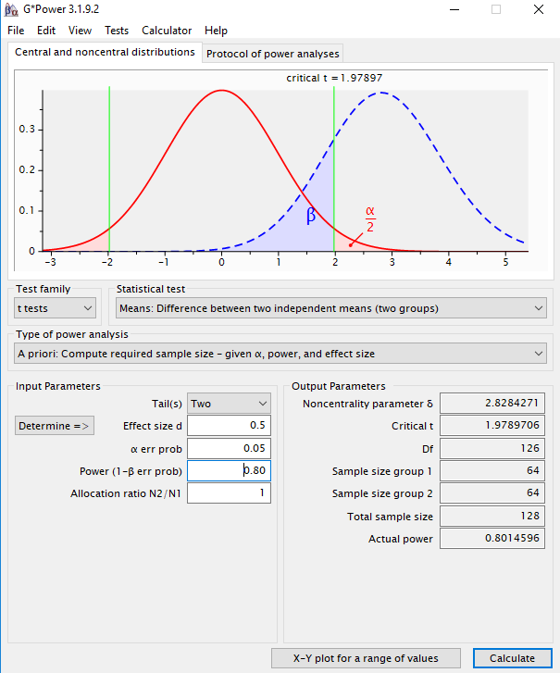

**Participants and Procedure**

Participants took part in an online experiment via Prolific Academic in exchange for monetary reimbursement. Exclusion criteria were applied resulting in the following sample: participants between 18-45; English as a first language, 75% or greater rating on the website in terms of participation quality, had not participated in any other study in our lab (liplab.be), had completed at least one other study on the Prolific Academic platform.

**Materials.**

**Stimuli.**

**Conditioned stimuli** (*people*). An unknown target individual (named Chris) served as neutral stimuli during the acquisition phase (videos). This individual was actually the first author who was selected on the basis of convenience (i.e., it was easier to create and edit the videos myself rather than employ an actor or alternate source). The individual appeared during the video while his images also served as one set of category stimuli during the IAT. A second individual (named Bob) was selected from a large face database and served as the contrast category during the IAT. ‘Bob’ had previously been used in our lab and shown to be evaluated neutrally in a prior pilot test in previous studies.

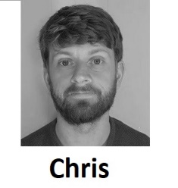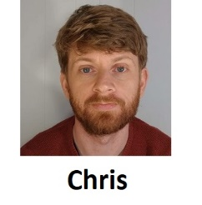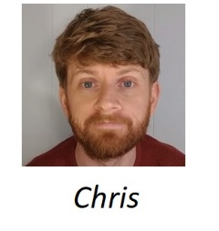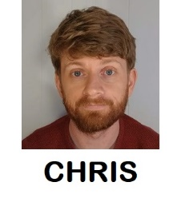

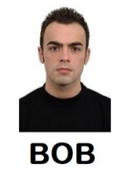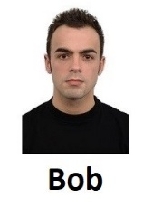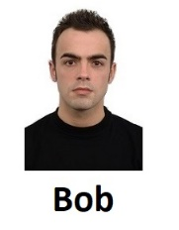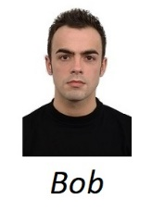

**Unconditioned stimuli (***behavioral statements***)**. Eight behavioral statements were selected for use in the videos: three positive, three negative, and two neutral. These items were selected from a larger pool of statements that were pre-tested along three dimensions: valence, believability, and diagnosticity (i.e., the extent to which they reflect something about a person’s ‘true’ character) (the pilot testing materials and analyses can be found in the OSF page associated with this study).

*Positive statement 1*: Ok. Question number 2. What do you do when you are not making these videos? Well I recently started to volunteer at my local soup kitchen. It is a great idea to give back to your local community and help those in need.

*Positive statement 2*: Ok and now for Question number 3. Do you still believe in chivalry? Yes – I do. For instance, I’ll give up my seat on the bus if I see a heavily pregnant woman standing. She needs it more than I do.

*Positive statement 3*: Now for question number 5. I notice that you make most of your videos during the week. How do you typically spend your weekends? Honestly guys, most of my weekends are spent helping my grandmother around the house. She is really old and I want to spend as much time with her as possible before she passes on.

*Negative statement 1:* Have you ever been in a car accident? No but I did drive home very drunk from the bar last weekend. I probably shouldn’t have because I hit a dog that ran out in front of me. But I didn’t get hurt and no one else did on the road.

*Negative statement 2*: Do you have any stories from your time in college? Well when I was in college I managed to cheat on my final exam. It definitely took a lot of effort but also was definitely worth it.

*Negative statement 3*: What is it with you and talking about cashiers in your videos? Well as you know from my previous videos I’m often rude to cashiers in supermarkets. They take way too long and get paid way too much.

*Neutral statement 1*: Question number 1: do you have any siblings? Yes – I have two siblings – a brother called Ted and a sister called Susan. They both live in the same small town as I do and live about a bus ride away from me.

*Neutral statement 2*: Have you recently changed something in your videos? Something seems different? Thanks for asking. As I mentioned in my last video time I just moved to a new apartment. I’ve also got a new haircut and bought a new bookshelf for my bedroom.

**Personalized IAT**. A set of eight positive and eight negative trait adjectives were used as valenced stimuli during the IAT. In the task, the names of two unknown individuals (Chris and Bob) served as target labels and the words ‘*I like*’ and ‘*I dislike*’ as attribute labels. Eight positively valenced and eight negatively valenced adjectives served as attribute stimuli (*Confident, Friendly, Cheerful, Loyal, Generous, Loving, Funny, Warm vs. Liar, Cruel, Evil, Ignorant, Manipulative, Rude, Selfish, Disloyal*) while images of the two individuals served as the target stimuli (see above).

**Procedure**

Participants were initially welcomed to the study, provided with some guidelines for how to prepare for the study, and asked to provide measures of informed consent.

**Demographics**. We then asked them to self-report their age and gender.

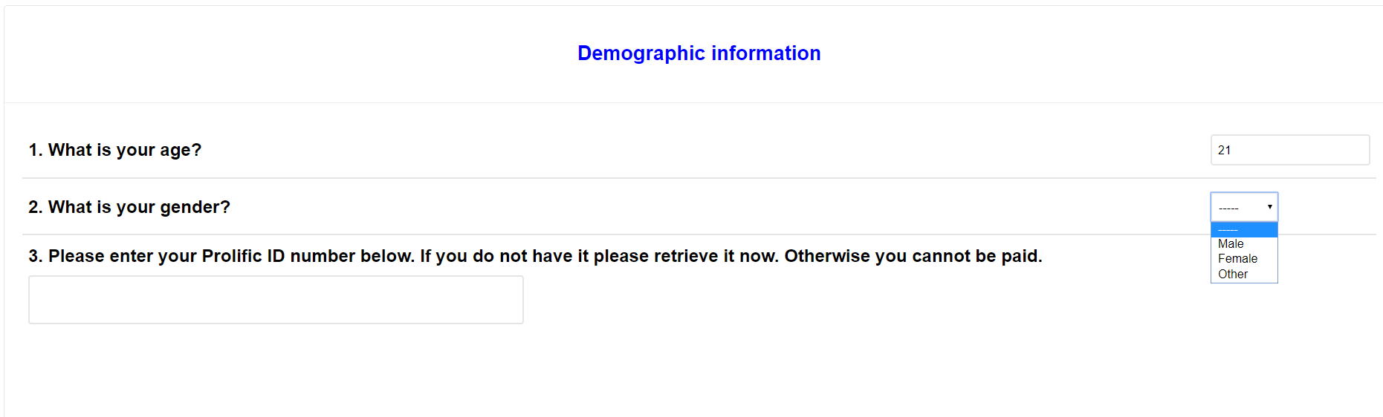

**Acquisition phase (***video***)**.Participants were provided with the following instructions:

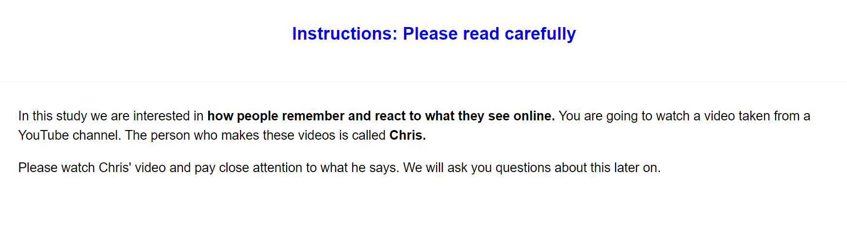

“*In this study we are interested in how people remember and react to what they see online. You are going to watch a video taken from a YouTube channel. The person who makes these videos is called Chris. Please watch Chris' video and pay close attention to what he says. We will ask you questions about this later on*.”

Thereafter they watched a short video of Chris who emitted three valenced statements and two neutral statements (for a copy of the entire video see this osf project page). Half of the participants encountered a positive variant video wherein Chris emits three positive and two neutral statements, whereas the other half encountered the negative variant video, wherein Chris emits three negative and two neutral statements (for the actual statements used see the video and the stimulus section above).

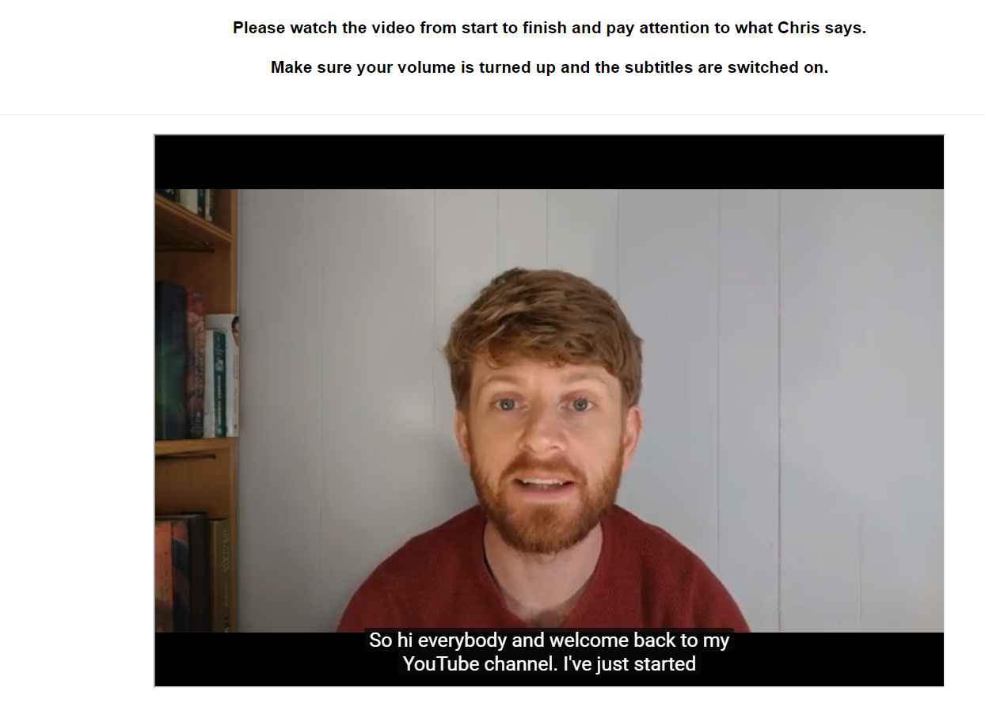

**Personalized IAT**. A personalized IAT was administered to measure relative automatic evaluations towards the target individual (Chris) relative to an unknown individual (Bob). Participants were informed that they would encounter two individuals (Chris and Bob) in the next task as well as the words ‘I like’ and ‘I dislike’ (attributes) which would appear on the upper left and right sides of the screen, and that stimuli could be assigned to these categories using either the left (‘E’) or right keys (‘I’). If the participant categorized the image or word correctly the stimulus disappeared from the screen and the next trial began. In contrast, an incorrect response resulted in the presentation of a red ‘X’ which remained on-screen followed by the next trial. Overall, each participant completed seven blocks of trials. The first block of 16 practice trials required them to sort images of Chris and Bob into their respective categories, with Chris assigned to the left (‘E’) key and Bob with the right (‘I’) key. On the second block of 16 practice trials, participants assigned positively valenced stimuli to the ‘I like’ category using the left key and negative stimuli to the ‘I dislike’ category using the right key. Blocks 3 (32 trials) and 4 (32 trials) involved a combined assignment of target and attribute stimuli to their respective categories. Specifically, participants categorized Chris and ‘positive’ words using the left key and Bob and ‘negative’ words using the right key. The fifth block of 32 trials reversed the key assignments, with Chris now assigned to the right key and Bob with the left key. Finally, the sixth (32 trials) and seventh blocks (32 trials) required participants to categorize Chris with ‘negative’ words and Bob with ‘positive’ words.

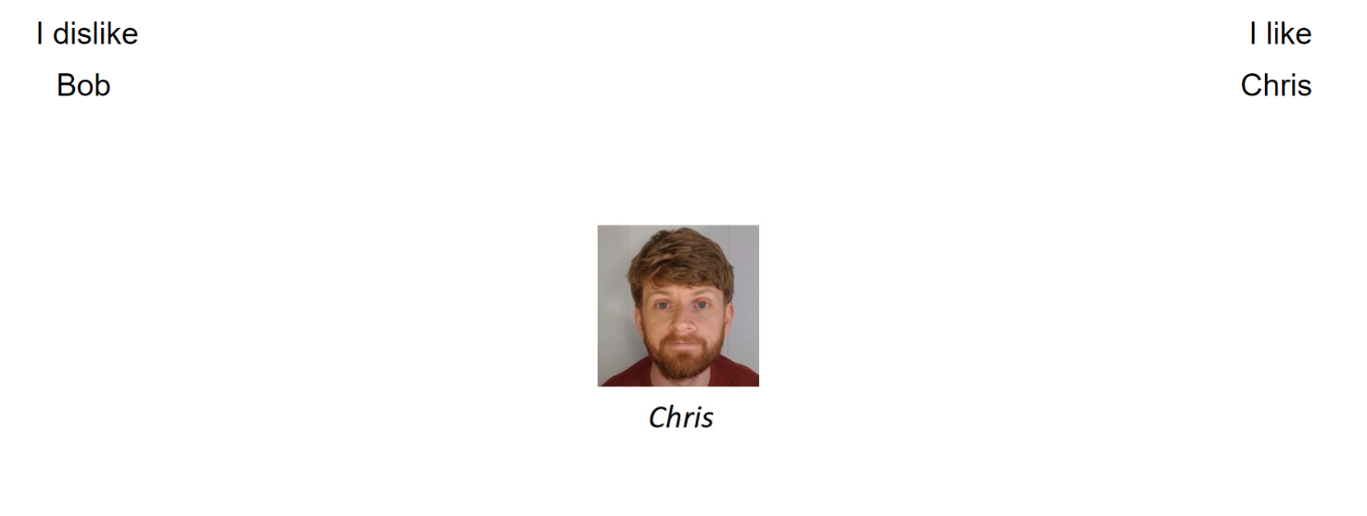

**Self-report measures**. Explicit liking towards Chris were assessed using different questions. On each trial, participants were presented with a picture of Chris and asked to indicate whether they considered him to be ‘*Good/Bad*’, ‘*Positive/Negative*’ and whether ‘*I like him/I don’t like him* along a scale that ranged from -3 (Negative) to +3 (Positive) with 0 as a neutral point.

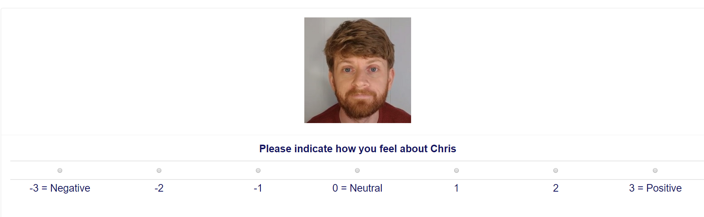

**Exploratory questions**.

**Video memory**. We assessed whether participants could accurately recall the various statements that Chris made during the video. Participants were told: “1. Earlier, we showed a Youtube video from a person called Chris. Can you remember the main things that Chris said in his video. Please try to remember as much from the video as possible.” And provided with a textbox in which to respond.

**Diagnosticity of the statements**. Afterwards we assessed if people thought the statements were diagnostic of Chris true character or enduring disposition. Specifically, we asked them “During the video Chris provided information about himself. Do you think that this information revealed something about the type of person Chris really is (i.e., his true character)?” and provided with four response options:

The info completely revealed Chris' true character

The info was moderately revealing of Chris' true character

The info only slightly revealed Chris' true character

The info revealed nothing about Chris' true character

**Demand**. We assessed if people’s evaluations were primarily driven by demand. We asked them “Earlier, we asked you to indicate how you felt about Chris (e.g., whether he was good or bad). Did you tell us the truth about how you felt? Or did you just fake your response (i.e., tell us what you thought we wanted to hear)? Please be honest here (it will not affect payment in any way)”. Response options were as follows:

“Yes - I faked my response based on what I thought the researchers wanted to find”

“No - my responses were based on how I genuinely felt”

“I don't know”

**Reactance**. We assessed reactance by asking: “Earlier, we asked you to indicate how you felt about Chris (e.g., whether he was good or bad). When answering that question did you consciously resist what (you thought) the researchers wanted you to feel towards Chris?” Response options:

Yes- I resisted what I thought the researchers wanted me to say

No - my responses were based on how I genuinely felt

I don't know

**Hypothesis awareness**. We assessed if people were aware of the experimental agenda behind the experiment. Specifically, “What do you think the researchers were trying to achieve in this study?” Response option: open ended.

**Influence awareness.** We assessed ifparticipants were aware if the video influenced their subsequent evaluation of Chris. Specifically “Think back to the YouTube video we showed you. Do you think this video influenced how much you subsequently liked or disliked Chris? Please be honest here” Response open ended.